

PANGANI GIRLS’ KCSE PREDICTION
EXAM TEST-2025
232/3
PHYSICS
PRACTICAL
PAPER 3
TIME: 2½ HOURS

NAME…………………………………………………………………………………………
SCHOOL………………………………………………. SIGN……………………..
INDEX NO ……………………………………………. DATE…………………….

Kenya Certificate of Secondary Education.

232 / 3
PHYSICS
PAPER 3
TIME: 2 HRS 30 MIN

INSTRUCTIONS
Answer all the questions in the spaces provided

Question 1:
Each student will require the following
- 2 new dry cells (size D)
- A cell holder
- A switch
- An ammeter (0-2.5A)
- A voltmeter (0 – 5v)
- 6 connecting wires
- 2 crocodile clips
- A nichrome wire 1.0m long mounted on a scale (SWG 32) labeled X
- A micrometer screw gauge (can be shared)

Proceed as follows
a) Connect the circuit as shown in the figure below

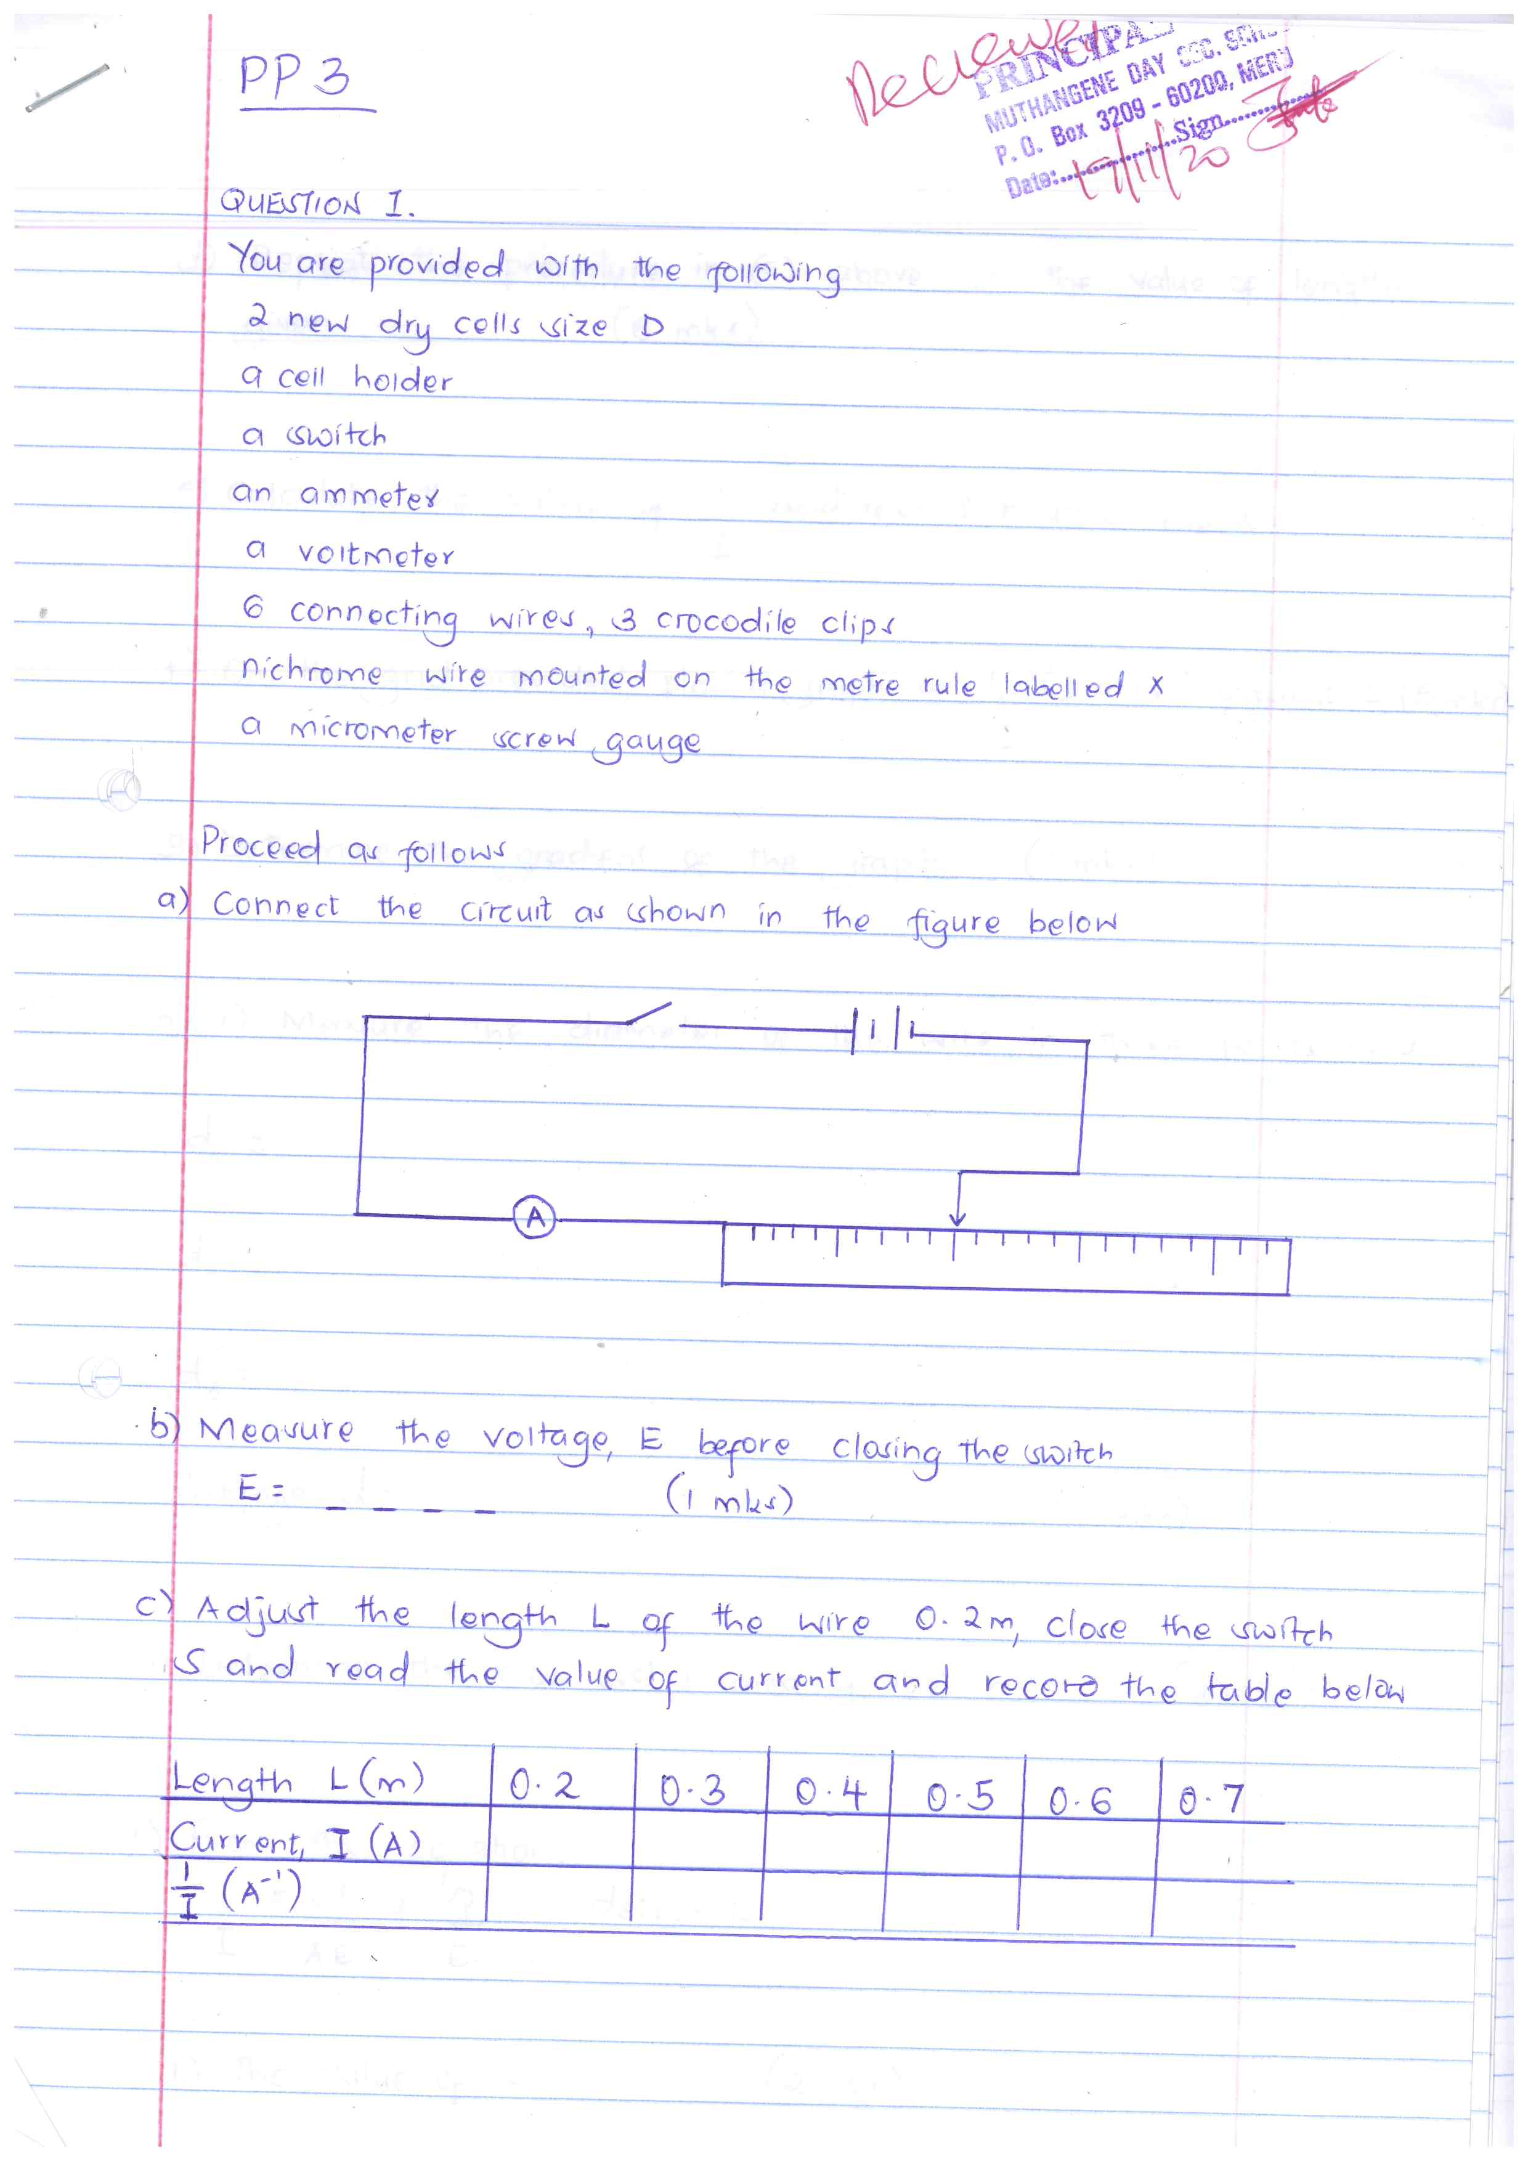

b) Measure the voltage, E ( across the cells) before closing the switch
E= ………………………………….. (1mk)

c) Adjust the length L of the wire 0.2, close the switch S and read the value of current and record the table below
Length L(m) | 0.2 | 0.3 | 0.4 | 0.5 | 0.6 | 0.7
Current I (A)
$\frac{1}{I}$ (A⁻¹)

d) Repeat the procedure in (c) above for the value of lengths given 6mks)

e) Calculate the values of $\frac{1}{I}$ and record in table above

f) On the grid provided, plot a graph of $\frac{1}{I}$ (y axis) against L 5mks)

g) Determine the gradient of the graph 3mks)

h) i) Measure the diameter of the wire in three points used
d₁ =

d₂=

d₃ =

Average d= 1mk)

ii) Determine the cross section area of the wire 2mks)
i) From the equation
$\frac{1}{I}$ = $\frac{kL}{AE}$ + $\frac{Q}{E}$ determine,

i) The value of k 2mks)

ii) The value of Q 1mk)

QUESTION 2.
Section A
You are provided with the following
- A candle
- A lens and a lens holder
- A screen
- A metre rule

a) Set up the apparatus as shown in figure below (ensure that the candle flame and the lens are approximately the same height above the bench)
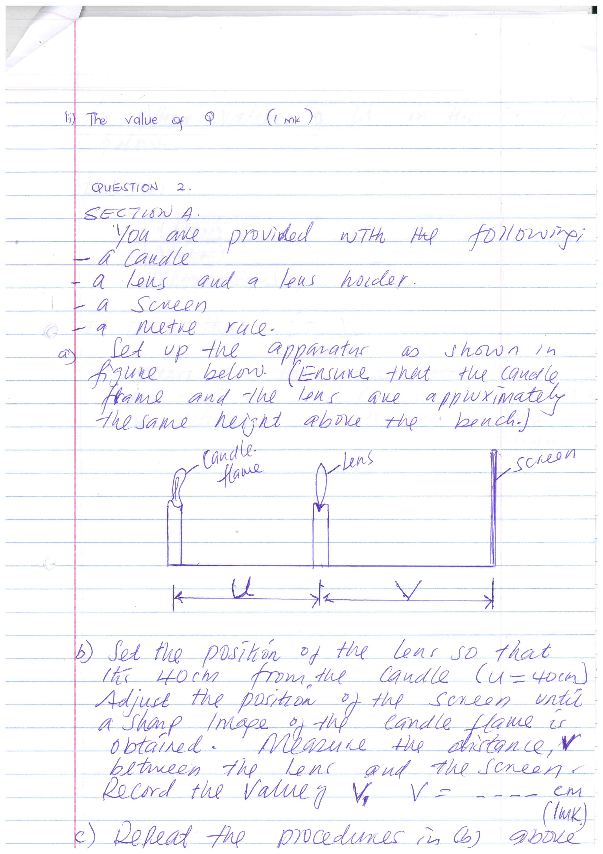

b) Set the position of the lens so that the 40cm from the candle (U=40). Adjust the position of the screen until a sharp image of the candle flame is obtained. Measure the distance, V between the lens and the screen. Record the value of V₁ V = ………… cm) 1mk)

c) Repeat the procedures in b) above for other values of U in the table b below.
Table b)
U(cm) | 45 | 50 | 55
V(cm)
Magnification (m) $\frac{v}{u}$

d) Given that f = $\frac{v}{m+1,}$where f is the focal length of the lens, use the results in table above to determine the average values of f. 4mks)

PART B.
You are provided with the following:
- rubber bung.
- vernier calipers.
- beam balance.

Proceed as follows:
- Using a vernier caliper, measure the lengths D, d, and h as shown in figure 2.
d
h
D
D = ....................................................... m (1 mark)

d = ........................................................ m (1 mark)

h = ........................................................ m (1 mark)

- (i) Measure the mass, M of the rubber bung using the beam balance.
M = ....................................................... kg (1 mark)

d + D
4
(ii) Given that Q = , determine the value of Q. (1 mark)

M
h
(iii) Determine the value of r given that πrQ² = (3mark)

(iv)what are the units of r (1 mrk)

(v) what is the significance of r (1 mrk)

SECTION C
You are provided with the following
- a metre rule
- a retort stand, one boss, one clamp
- One 500ml beaker ¾ full of water
- One 100g mass
- One 50g mass
- 3 pieces of thread approximately 30cm long

Procedure
a) Balance the metre rule horizontally by suspending it from the stand and clamp with one of the threads.
Record the balance point G

G = __________________ cm 1mk)

b) suspend the 100g mass from the metre rule at a point such that x =5cm from point G, with the 100g mass completely immersed in water in the beaker hang the 50g mass from the metre rule.
Note the point of suspension (p) of the mass
P=______________1mk)

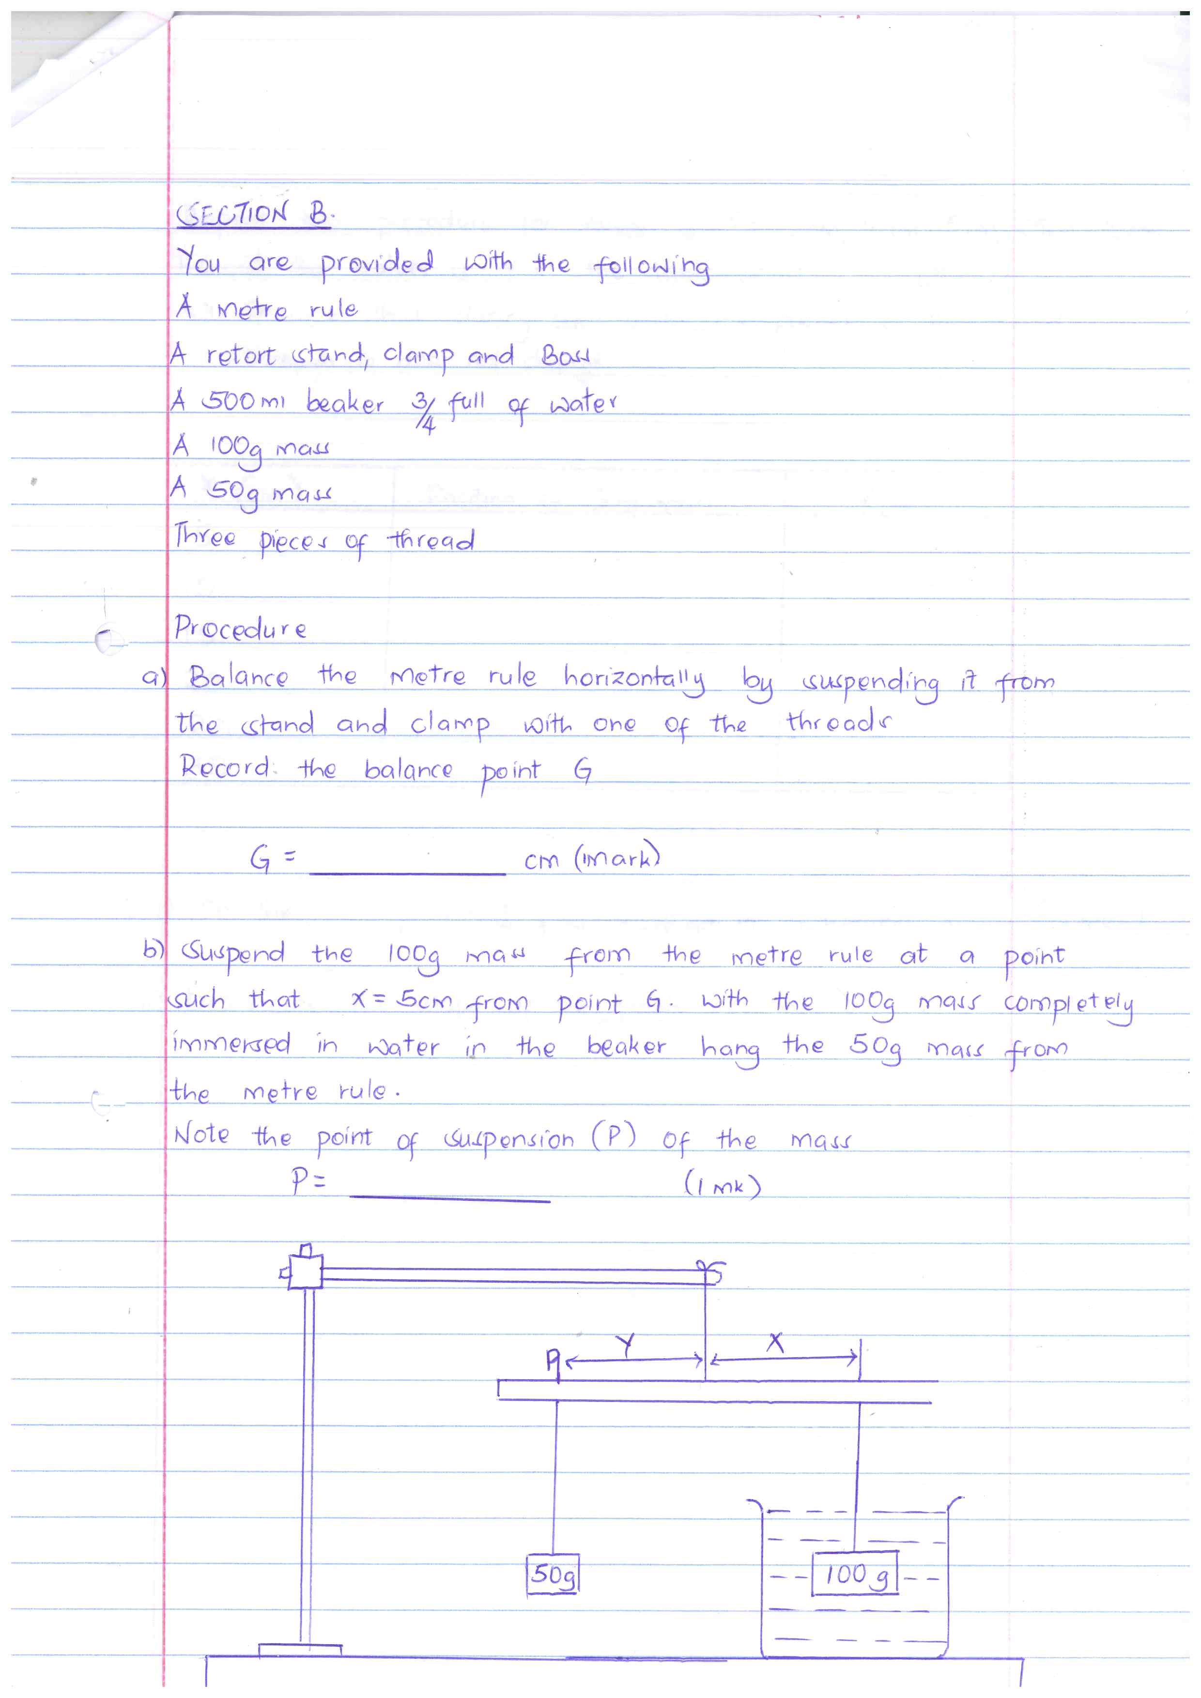

c ) Calculate the apparent weight of the 100 g mass in water. 3mk)

d)Find the upthrust of 100g mass in water. 2mk)

